VILLAGE OF BARTON
WASTEWATER TREATMENT FACILITY IMPROVEMENTS
BOND VOTE INFORMATIONAL FLYER

When is the public information meeting and site visit?

PUBLIC INFORMATION MEETING
Barton Village Memorial Building
17 Village Square, Barton, VT 05822
Tuesday, February 10, 2026 @ 6:00 p.m.

SITE VISIT
Barton Wastewater Plant
112 Municipal Lane, Barton, VT 05822
Wednesday, February 11, 2026 @ 1:00 p.m.
5:00 p.m.

When is the bond vote?

BOND VOTE – AUSTRALIAN BALLOT
Barton Village Memorial Building
17 Village Square, Barton, VT 05822
Thursday, February 12, 2026
10:00 a.m. to 7:00 p.m.

What is the project?

The project includes the following:
- Removal of accumulated sludge in both lagoons.
- Age-related equipment upgrades and safety-related improvements at the Main Pump Station.
- Expansion and refurbishment of both existing lagoons.
- Addition of a third lagoon.
- Age-related upgrades and safety-related improvements at the Wastewater Treatment Facility (WWTF).
Why is it necessary, how much will it cost, and how will it be paid for?

Much of the equipment at the WWTF has been in service for over 45 years. Typical WWTF equipment has an expected life of 20-25 years.

To continue to provide reliable treatment for the public and environmental health, the critical components being upgraded in this project are recommended to avoid failure or replace equipment that has already failed.

Of the estimated $10.87-million cost, the Village is anticipated to receive at least a 50% grant from United States Department of Agriculture Rural Development (USDA RD). The remaining cost would be paid off with a 30-year loan at a 3.125% interest rate, and with grant funding through other agencies.

Payments would begin one year following the completion of construction. Only sewer customers will pay for the project. The project’s impact is currently estimated to increase sewer charges by up to $29 per month per customer.

What is included in the improvements?
- Main Pump Station – new process equipment such as a sewage grinder, grit classifier, etc.
- Main Pump Station – safety improvements such as ventilation upgrade and gas detection.
- WWTF (lagoons) - sludge cleanout, new liners and aeration system, expansion of existing two (2) lagoons, addition of a third lagoon.
- WWTF – new process equipment such as chemical feed systems, tank covers, etc.
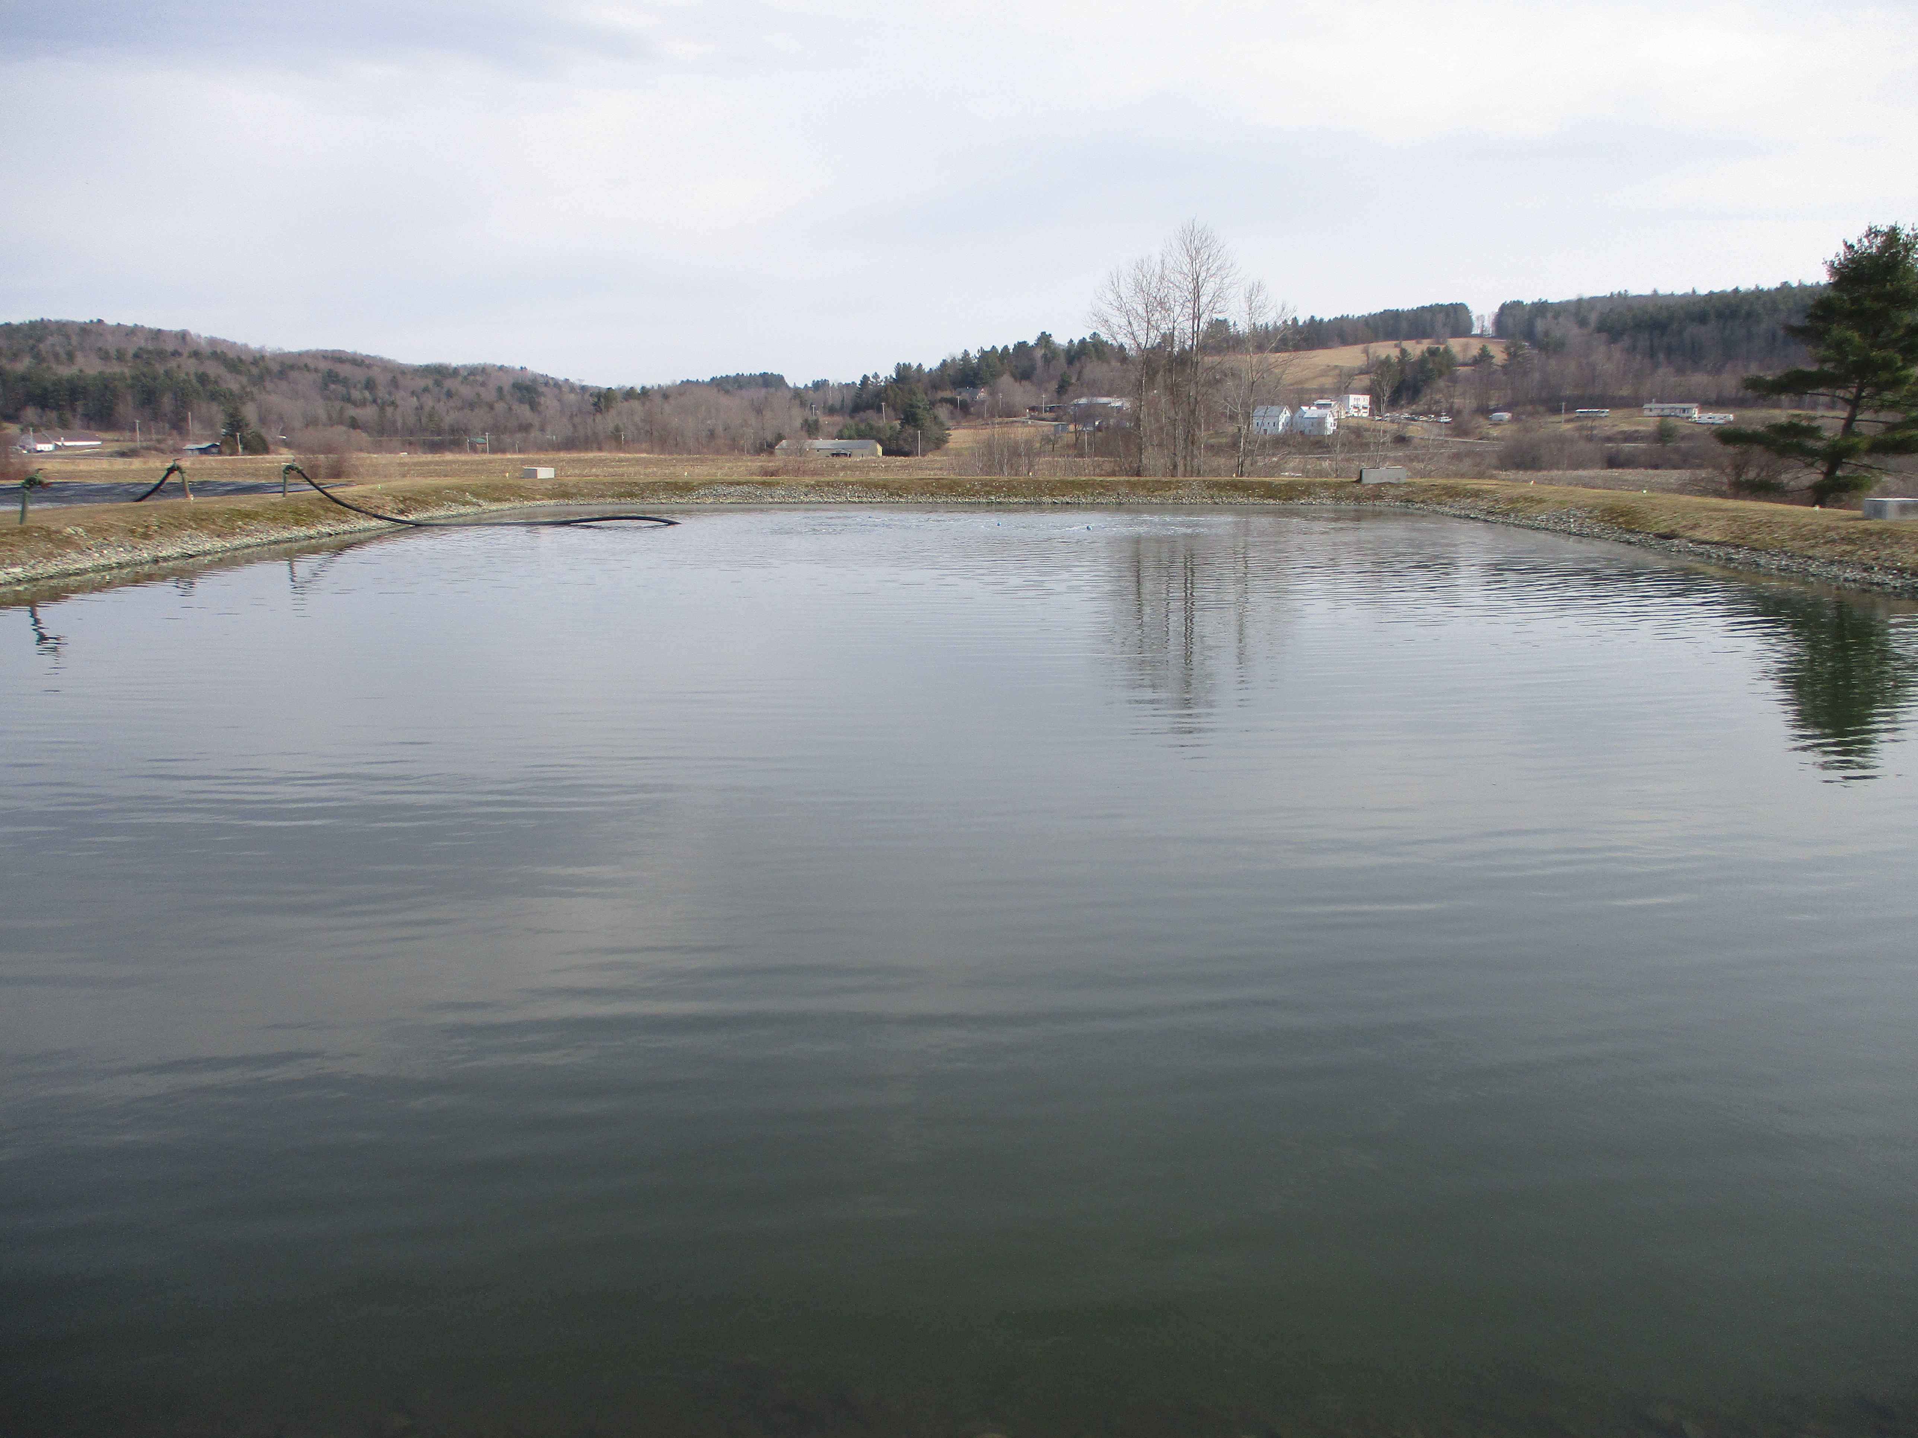

- WWTF – safety and energy efficiency improvements such as waterproofing and ventilation upgrades.

What is the project cost and bond amount?

Item Description | Estimated Cost
Construction | $8,050,000
Construction Contingency | $1,207,500
Technical Services | $1,482,600
Legal/Administration | $55,000
Fees/Interest | $70,000
Estimated Total Project Cost | $10,865,100
Total Bond Amount | $10,870,000

What is the project schedule?

Projected Date |  | Task
2026 | February | Hold Bond Vote
2026 | April | Start Final Design,  Bid Advertisement – Lagoon Cleanout
2026 | September | C#1 – Lagoon Cleanout
2027 | February | Bid Advertisement – C#2 (WWTF & PS)
2027 | July | C# 2 – Construction Starts
2028 | September | C#2 – Substantial Completion
2029 | July | End of One-Year Warranty Period,  Bond Payments Start

What are the available funding sources?

USDA Rural Development (USDA RD) offers a combination of grants and loans, with interest rates currently at 3.125% and with grants up to 75%.

The State of Vermont Clean Water State Revolving Fund (CWSRF) has a planning subsidy this project has qualified for in the amount of $300,000.

Based on the total project cost, economic conditions of the Village, wastewater-related debt service, and USDA program requirements, anticipated loan terms would be 3.125% over 30 years and a 50% grant. The annual cost to the Village would be approximately $266,235. For a typical sewer user, this equates to an increase of $350 annually, or $29 per month.

Supplemental grants through programs such as the State of Vermont Pollution Control (PC) program, Northern Borders Regional Commission (NRBC), and/or US Department of Commerce Economic Development Administration (EDA) could lessen the payment amount, and the Village is actively pursuing these funds.

